**MERN Stack Using ShopEZ: E-Commerce Application**

**Department of Computer Science and Engineering**

Submitted By

**1. SHARIQ AKTHAR 110121104092**

**2. MOHAMED KAIF 110121104054**

**3. SAYED ALNAASH 110121104088**

**4. MOHAMMED ISMAIL 110121104053**

**Abstract**  
The project report presents *ShopEZ*, an e-commerce platform developed using the MERN stack (MongoDB, Express.js, React.js, Node.js). The application is designed to simplify the online shopping experience for users like Sarah, who need to find personalized products quickly and efficiently. Through features like effortless product discovery, personalized recommendations, seamless checkout, and efficient order management, ShopEZ aims to streamline the online shopping process for both buyers and sellers.

**Introduction**

* **E-commerce Growth and Importance:**  
  E-commerce platforms have revolutionized the way people shop, offering convenience and efficiency. However, with the growing number of options, finding the right product can be a time-consuming task. ShopEZ addresses this challenge by offering a personalized and seamless shopping experience for both customers and vendors.
* **Overview of ShopEZ:**  
  ShopEZ is a modern e-commerce platform built with the MERN stack. It is designed to cater to the needs of busy users like Sarah who are looking for a quick and efficient way to shop. By integrating product discovery, recommendation algorithms, secure checkout, and order management in a single platform, ShopEZ enhances the e-commerce experience.

**Problem Statement**

* Many e-commerce platforms today overwhelm users with too many options and lack personalized recommendations, making the shopping process inefficient.
* Busy professionals, like Sarah in the given scenario, need a more streamlined and customized shopping experience, which ShopEZ aims to provide.

**Objective of the Project**

* **Primary Objective:** To develop an e-commerce platform that simplifies product discovery and purchasing using a user-friendly interface and intelligent algorithms.
* **Secondary Objectives:**
  + Implement personalized recommendations based on user preferences.
  + Provide a secure and seamless checkout process.
  + Build an efficient order management system for sellers.

**Technology Stack**

* **MongoDB:** Database used to store product listings, user data, and order details.
* **Express.js:** Web framework for building the server-side of the application.
* **React.js:** Frontend library used for building the user interface and managing state.
* **Node.js:** Backend runtime for building scalable network applications and handling server-side logic.
* **Other Technologies Used:**
  + **JWT (JSON Web Token)** for secure user authentication.
  + **Stripe API** for payment processing.
  + **Nodemailer** for email notifications.

**System Design and Architecture**

* **Frontend (React.js):**
  + **User Interface:** Components like product catalog, filters, search bar, product details, shopping cart, and checkout forms.
  + **State Management:** React's state management (via hooks or context API) to manage user actions like cart updates and login status.
* **Backend (Node.js & Express.js):**
  + **RESTful APIs** for product management, user registration/login, checkout process, and order management.
  + **User Authentication:** Using JWT for secure login and session management.
  + **Product Recommendations:** A recommendation engine using user data and product preferences to personalize suggestions.
* **Database (MongoDB):**
  + Collections for storing product details, user profiles, orders, and reviews.

**ER-Model**

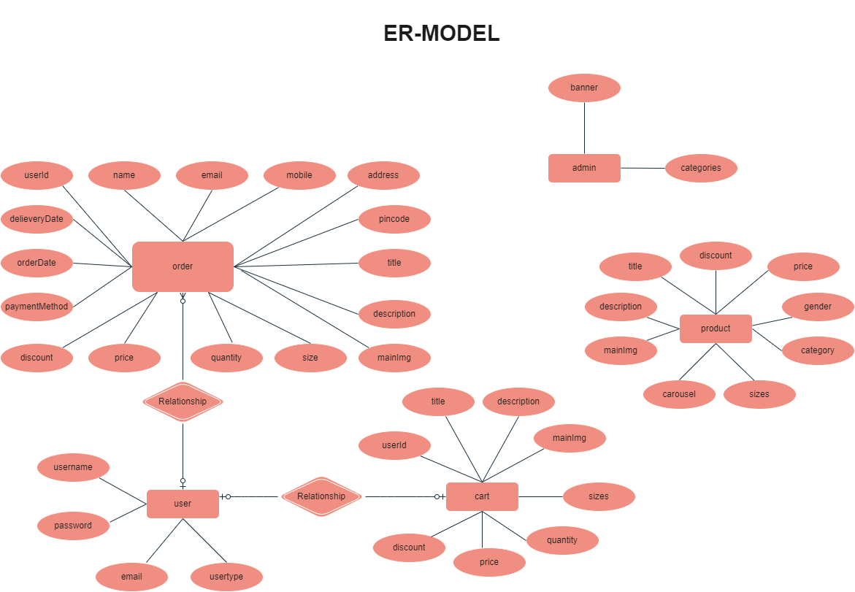

**Implementation**

* **Product Discovery:**  
  Users can filter products based on categories, price range, and other attributes. The React frontend allows seamless interaction with these filters to help Sarah easily narrow down her search to find the right bracelet for Emily.
* **Personalized Recommendations:**  
  ShopEZ leverages machine learning or simple recommendation algorithms (based on user behavior and preferences) to suggest products like the gold bangle for Sarah. This feature enhances user engagement and encourages more purchases.
* **Secure Checkout:**  
  The checkout process allows users to input shipping details, choose payment methods (via Stripe), and review their orders. The payment gateway is integrated securely to ensure safe transactions.
* **Seller Dashboard & Order Management:**  
  Sellers have a dedicated dashboard where they can view and process orders, update product inventory, and manage shipments efficiently. Order updates are automatically reflected in the user’s account.

**Features and Functionality**

* **User Registration and Login:**  
  Users can create an account, log in, and view their purchase history. Authentication is handled via JWT tokens for secure access.
* **Product Filtering and Search:**  
  Users can search for products by keywords, and apply filters such as price, category, and style.
* **Recommendation System:**  
  Personalized recommendations are generated based on the user's past browsing behavior and preferences.
* **Shopping Cart & Wishlist:**  
  Users can add items to their cart or wishlist, save them for later, and proceed to checkout.
* **Order Management for Sellers:**  
  Sellers can view orders in real time and update product availability and shipment status.

**Challenges and Solutions**

* **Challenge 1: Handling Personalized Recommendations**  
  The recommendation algorithm was initially difficult to optimize. We solved this by using user data (search history, purchase behavior) to create more refined recommendations.
* **Challenge 2: Secure Payment Gateway Integration**  
  The integration with Stripe was complex but was resolved by using their official SDK, ensuring secure and reliable transactions.
* **Challenge 3: Performance Optimization**  
  As product listings grew, we implemented lazy loading and pagination for better performance.

**Conclusion and Future Work**

* **Conclusion:**  
  ShopEZ successfully meets the needs of busy users like Sarah by providing an intuitive, personalized, and efficient shopping experience. By utilizing the MERN stack, we have created a platform that is both scalable and easy to maintain.
* **Future Work:**
  + Expand the recommendation system with more sophisticated algorithms (e.g., collaborative filtering).
  + Integrate more payment options.
  + Enhance the mobile responsiveness of the application for better user accessibility.